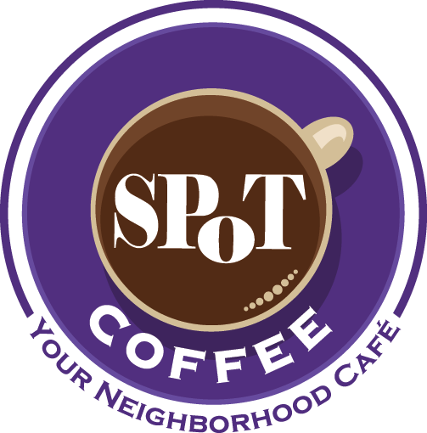
®
SPoT Coffee® Full Café Preliminary Franchisee Information Form
Please complete this form by providing answers to the following questions in this Word document and returning the completed document to SPoT Coffee® for our review.

- General Information

- What is your full legal name?

- What is your current residential address including city, state and zip code?

- What is your primary telephone number and email address?

- What is the best time to contact you with regard to this application?

- How did you hear about SPoT Coffee®, and are your familiar with our concept? Let us know if you have been to any SPoT Coffee® locations in New York State.

- Do you have any experience operating (or operating in) a franchise food and beverage service establishment? If so, please indicate how long you were involved in the operation.

- What unencumbered funds do you currently have available? Please indicate if you feel that you are able to provide SPoT Coffee® with the required initial franchise fee for a full SPoT Coffee® café location, as well as the additional funds required to complete the build-out.

- Do you have any co-applicants, or will your SPoT Coffee® franchise location be purchased by a corporation with multiple owners? If so, please provide us with relevant details and contact information, as well as a description of the proposed contribution to your franchise café.

- Are you an owner-operator?
YES □
NO □

- Are you currently employed or self-employed? If you are currently employed, please provide us with some details about your employer and how long you have been employed in your current position. If you are self-employed, please provide us with some details regarding your business.

- Are you now, or have you ever been, party to any lawsuit (either as Plaintiff or Defendant)?

- Have you ever been convicted of a felony either in the United States or abroad?

- What is your top choice for your SPoT Coffee® franchise location?¹ Please provide the name of the city or town in New York State where you would like the SPoT Coffee® real estate team to focus on finding a location.

- What income are you hoping to generate on an annual basis?

- How long can you support yourself without making withdrawals from your business?

1 Full SPoT Coffee® locations range in size between 2,500 sq. ft. and 3,500 sq. ft. The town or city in which a SPoT Coffee® is located must have a population no smaller than 30,000 non-transient residents. All full SPoT Coffee cafés must be on major street corners and/or pedestrian thoroughfares. Our Franchise Team will provide you with further details once this form has been submitted and reviewed.

