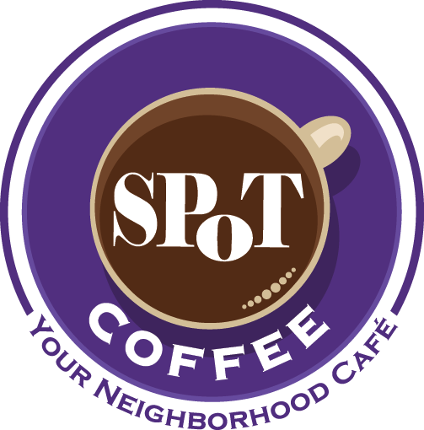
®
SPoT Coffee® Express Preliminary Franchisee Information Form
Please complete this form by providing answers to the following questions in this Word document and returning the completed document to SPoT Coffee® for our review.

- General Information

- What is your full legal name?

- What is your current residential address including city, state and zip code?

- What is your primary telephone number and email address?

- What is the best time to contact you with regard to this application?

- How did you hear about SPoT Coffee®, and are your familiar with our concept? Let us know if you have been to any SPoT Coffee® locations in New York State.

- Do you have any experience operating (or operating in) a franchise food and beverage service establishment? If so, please indicate how long you were involved in the operation.

- What unencumbered funds do you currently have available? Please indicate if you feel that you have the capital available to provide SPoT Coffee® with the required initial Express franchise fee, which varies depending on the type of Express location (counter, kiosk or micro café), as well as the additional funds necessary to complete the build-out.

- Do you have any co-applicants, or will your SPoT Coffee® franchise location be purchased by a corporation with multiple owners? If so, please provide us with relevant details and contact information, as well as a description of the proposed contribution to your franchise café.

- Are you an owner-operator?
YES □
NO □

- Are you currently employed or self-employed? If you are currently employed, please provide us with some details about your employer and how long you have been employed in your current position. If you are self-employed, please provide us with some details regarding your business.

- Are you now, or have you ever been, party to any lawsuit (either as Plaintiff or Defendant)?

- Have you ever been convicted of a felony either in the United States or abroad?

- What is your top choice for your SPoT Coffee® franchise location?¹ Please provide the name of the city or town in New York State where you would like the SPoT Coffee real estate team to focus on finding a location.

- What income are you hoping to generate on an annual basis?

- How long can you support yourself without making withdrawals from your business?

1 SPoT Express locations must not exceed 1,500 sq. ft. and must be located in a high traffic environment such as a shopping mall, commerce court, commercial pathway, high volume service business (fuel station) and hotel or transportation hub (such as an airport or train station). Our Franchise Team will provide you with further details once this form has been submitted and reviewed.

